**CHAPTER 1**

**Introduction**

A study by the U.S Department of Transportation has reported that the pavement surface conditions are an important factor for providing riding quality transportation experience. Speed bumps and potholes are one of the most annoying road features experienced by drivers, passengers and vehicles. Since speed and potholes can damage vehicles, cause unpleasant driving and, in many cases, be the reason for car crashes, it is widely accepted that ride quality and safety are greatly impacted by the anomalies in the roadway pavement surfaces.

Over the past ten years, roads in many developing countries have been allowed to deteriorate beyond the point where normal maintenance could not be effective. Traffic loading has been much heavier than intended, and maintenance has been widely neglected.

When road authorities are not able to afford maintenance work, the costs passed on to road users are larger than the "savings" in public expenditure. Over the life of a road, the total operating costs of vehicles are typically four to ten times the costs of road construction and maintenance.

The traditional approach to road damage detection is to use manual reporting of the presence of pavement surface anomalies. Another approach is to use existing technologies such as light detection and ranging or other commercial products such as Road scanners. The overall cost and maintenance of this equipment is very high which reduces the system’s feasibility. Currently, for example, in the USA specialized high-end vehicles capable of detecting and mapping roadway conditions are used; nevertheless, because of the high cost of operations pavement monitoring agencies typically assess pavement quality approximately only once per year even though it is widely accepted that the continuous monitoring of roadway anomalies would improve the ride quality and the safety of travelers. The key reason for this low frequency of inspections is the fact that current methods are expensive and laborious.

This project aims to propose a reliable automated mechanism to detect these anomalies and reduce the associated negative consequences. And also provide a Comfortable path to destination. This will be achieved through inertial sensor signals and Artificial Intelligence models.

This Project comprises external stimulus and Internal stimulus environment. External stimulus aims to understand the environment outside the vehicle, recognizing the road features on which it travels. These features include transient events in the form of anomalies and obstacles, such as potholes, cracks, speed bumps, etc., and persistent events, such as surface type, conservation condition, and the road surface quality. Internal Stimulus aims to understand vehicular movements to identify their own behavior. These identifications can also be transient in the form of driving events, such as Speed, Location, turning right or left. This situational information has wide applicability in Intelligent Transport Systems (ITS) such as Advanced Driver Assistance Systems (ADAS) and autonomous vehicles.

For the development of this project, datasets have been collected using GPS, camera, inertial sensors like accelerometers, gyroscopes, magnetometer. This dataset is prepared with contextual variations, such as driving at different speeds and traveling through different environments. to recognize and classify the different road patterns. A solution is developed using Artificial Intelligence called CNN. A GUI interface is also built to interact with the application and get the required path plotted i.e., Path shortest by length, Time, Comfortable.

In order to go further with CNN, it is required to preprocess the data collected. Where a process known as spectrogram conversion is used. Details of the spectrogram is given in next section

* 1. **Spectrogram**

A spectrogram is a visual way of representing the signal strength, or “loudness”, of a signal over time at various frequencies present in a particular waveform. Not only can one see whether there is more or less energy at, for example, 2 Hz vs 10 Hz, but one can also see how energy levels vary over time. In other sciences spectrograms are commonly used to display frequencies of sound waves produced by humans, machinery, animals, whales, jets, etc., as recorded by microphones. In the seismic world, spectrograms are increasingly being used to look at frequency content of continuous signals recorded by individual or groups of seismometers to help distinguish and characterize different types of earthquakes or other vibrations in the earth.

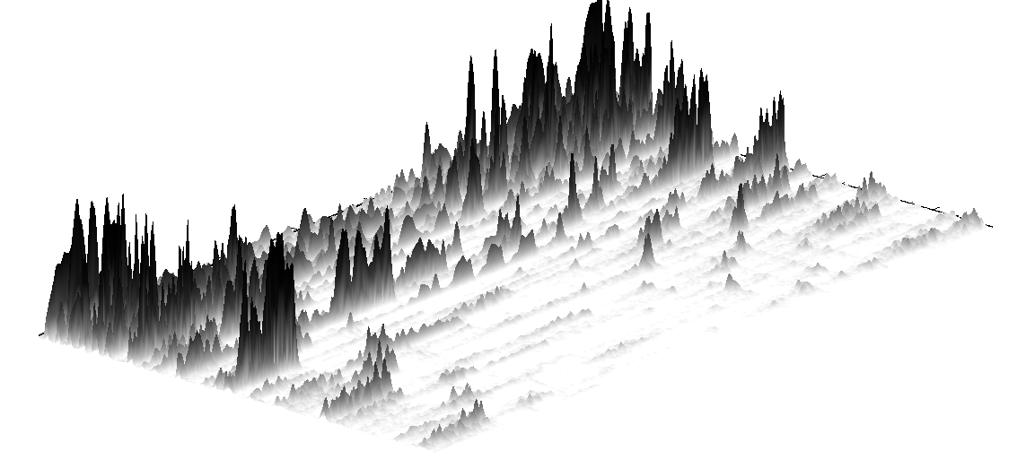

**Figure 1.1: 3D Surface of a wave**

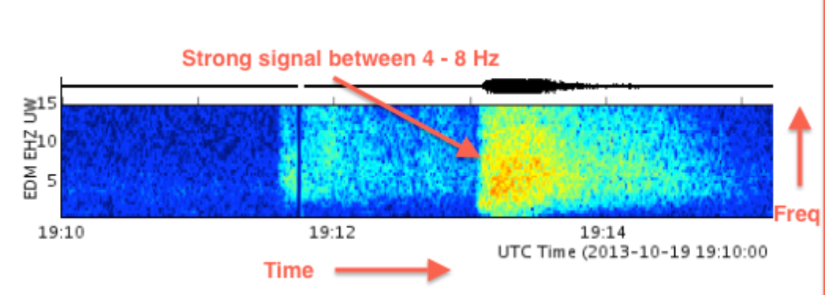

**Figure 1.2: 2D Representation of a wave (Spectrogram)**

While the spectrogram is mainly used for audio processing. It can also be used to process any types of waves which varies its strength along the time domain. As the vibrations caused by road anomalies produce the similar signals which varies with time. This Processing tech is been used to preprocess the collected data.

The next step is to build a deep learning model to classify road-based data collected. The detailed discussion of deep learning is given in next section.

* 1. **Deep learning**

Deep learning is a subset of machine learning, which is essentially a neural network with three or more layers. These neural networks attempt to simulate the behavior of the human brain—albeit far from matching its ability—allowing it to “learn” from large amounts of data. While a neural network with a single layer can still make approximate predictions, additional hidden layers can help to optimize and refine for accuracy.

Deep learning drives many artificial intelligence (AI) applications and services that improve automation, performing analytical and physical tasks without human intervention. Deep learning technology lies behind everyday products and services (such as digital assistants, voice-enabled TV remotes, and credit card fraud detection) as well as emerging technologies (such as self-driving cars).

While many deep learning techniques exists, the CNN (Convolutional Neural Network) has been chosen for implementing the model. Because CNN is considered as most effective architecture for image classification, retrieval and detection tasks as the accuracy of their results is very high. As Spectrogram is also an image representation of a signal it makes sense to use CNN for classification of road features.

CNN Layers

Inertial data

Spectrogram

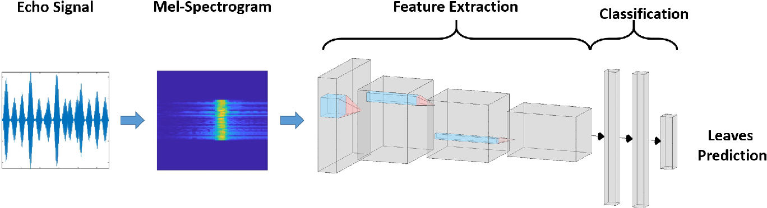

**Figure 1.3: Convolutional neural network (CNN)**

* 1. **Problem definition**

The most common problem that is faced in India is the maintenance of roads. The maintenance of roads mostly focusses on improper roads which are due to potholes, humps etc. The project mainly helps at detection of potholes, humps and road quality to plot it on maps to avoid accidents & help to transport critical instruments.

The main aim of this project is to is to help the people to find the best comfortable path to a destination i.e., To provide the best path that is more comfortable to drive having less speed humps, potholes and better-quality road.

The Module built will be detecting the speed humps potholes and other feature related to road quality, using the machine learning model by classifying the vertical acceleration, also using the GPS to store coordinates of the road being assessed. As the vehicle starts moving, the data will be collected and stored. This data will be used to train the ML Module.

The path being suggested is being plotted on the maps using OpenStreetMap, NetworkX, Folium python libraries by providing the data of source and destination and using the waypoints to direct the path.

* 1. **Objectives**

The objective of this project is to design and develop a prototype of an intelligent data gathering system that can be fitted in any transportation vehicle or car to detect the road or highway conditions. Followed by classifying the data and storing them in the database which can then be used to suggest a comfortable path to destination on G-maps.

The possible objectives of this project are.

1. To Gather Vehicular Data.

Data is the initial thing required to design a machine learning module. This data will be collected with all contextual variations i.e., with different speed, road etc. Using Inertial sensors (Accelerometer, Gyroscope and Magnetometer) and GPS Module.

1. To Preprocess the Data.

The Preprocessing the data is an initial step before carrying out the Training of the machine learning module. This process involves Preprocessing such as Data Slicing and labelling, Data Normalization, Feature Selection and Spectrogram Conversion.

1. To Classify the Data into Paths with Its Features (Potholes, Humps and Type of Road).

This objective involves building of machine learning module i.e., CNN (Convolutional neural networks). Which will be trained to be highly accurate to classify the road features.

1. To Compute the Comfortable Path Between Two Points.

This objective involves working on shortest path algorithm (Dijkstra algorithm). So that comfortable and safest path for the destination can be provided.

1. To Plot Routes and Road Quality Visually on Maps.

This Objective is to design a web interface where user can set the source and destination and a path comfortable will be provided with all humps and pothole markings and also can see the damage that road has taken.

* 1. **Organization of report**

Further report will discuss about chapter 2 literature survey, chapter 3 issues and challenges. chapter 4 proposed model, chapter 5 requirements of hardware and software, chapter 6 implementation, chapter 7 results and Conclusion.

**CHAPTER 2**

**Literature survey**

Literature survey helps in gaining an understanding on the fundamentals in the area on which the current work is being carried, this helps to learn the definitions of the concepts underlaying approaches, methods and theories of the different methods which were referred for this project. A numerous works has been reported in the literature related to spectrogram, choosing of the sensors, Machine learning approaches, path predictions and map plotting.

# Speed-bump Detection using Otsu's Algorithm and Morphological Operation (Nelson Kennedy Babu C, Deva Priya W., T. Srihari, Nandakumar) - 06/2020

Nelson et al., have used camera to capture the video of the road humps, which later this video is converted into image to detect road humps. They have used two methods Otsu’s threshold method and Morphological Operation method which have better accuracy in detecting road hump compared to the existing road hump detection method (Computer vision, Local neighbour, Canny edge). They claim that Otsu’s threshold method and Morphological Operation method have accuracy of 74.6% and 85.8% respectively.

**Limitation**: Nelson et al., work is limited to road humps that have been painted, there accuracy is not that good for non-painted humps. And, they do not identify the potholes, type of road (i.e., Asphalt Road, Muddy Road, Worn-out Road)

1. Pothole Detection and Notification Systems (Prof Shashikala J, Likith Rahul, Mahesh B, Nagabindu R, Preethi Muniraju) - 07/2020

Prof Shashikala et al., have used Ultrasonic sensor, GPS module, and Arduino board to detect the pothole and their depth and inform the local municipal committee with the exact location using GPS module. They also intimidate the driver about the pothole through LCD screen.

**Limitation**: Ultrasonic sensor has many disadvantages one among them is it needs hard surface for reflection of ultrasonic sound, if surface is soft there is chance that ultrasonic sound may not reach the sensor properly. Prof Shashikala et al., have not implemented the model practically on real time vehicle. And also, there model can’t detect road hump.

# Pothole and Hump detection system using IoT (Shyam Achary, Niraj Yadav, Sachit Agarwal, Pragya Jain, Deepak Das) - 12/02/2020

Shyam Achary et al., have used IOT sensor like Ultrasonic sensor, IR sensor, GPS module, NodeMCU to detect road hump and pothole. They have built an IOT robot (Prototype vehicle) using L298N Motor Driver, H-Bridge circuit, Pulse Width Modulator (PWM) and DC motor. They have also used Blynk open-source application to control the robot and display pothole location using map. Their application capable of sending email to the government with exact location of pothole and width and depth of pothole.

**Limitation**: Shyam Achary et al., have not tested model on real-time vehicle. And ultrasonic sensor is not efficient in detecting road humps and pothole.

# Piezoelectric Accelerometers (Johannes Wagner, Jan Burgemeister) - 2020

Johannes Wagner et al., have explained the working of Piezoelectric Accelerometer which is one type of accelerometer. Piezo sensors are used to measure the change in pressure, acceleration, or strain by converting them into electrical charge. The advantages of piezoelectric sensors are wide frequency bandwidth, high sensitivity, high signal-to-noise ratio, simple structure, reliable operation and light weight.

**Limitation**: Piezoelectric Accelerometers are very costly, and they are not used commonly.

# A Review Paper on Existing Pothole Detection Methods (Supratik Kumar Saha, Rishav Bhatt, Adit Gavankar, Prof. A.P. Singh) - 12/2018

In this paper Supratik Kumar Saha et al., have gone through different types of pothole detection method and came with 13 ways to detect road hump. Most of the ways to detect road humps are using camera and few are using IOT sensor.

**Limitation**: Using camera is very costly.

1. Road Surface Monitoring Using Smartphone Sensors: A Review ( [Shahram Sattar](https://sciprofiles.com/profile/490239), [Songnian Li](https://sciprofiles.com/profile/74677), [Michael Chapman](https://sciprofiles.com/profile/10794)) - 9/11/2018

Shahram Sattar et al., have used smartphone sensor in detecting road anomalies. Smartphone sensor like accelerometer, gyroscope, GPS, magnetometer have been taken use to implement this project. Accelerometer measures change in acceleration due to gravity in x, y, and z axis. By taking this and using machine learning road anomalies can be predicted.

**Limitation**: Sensors in mobile are not that powerful, they operate in low frequency.

# Detection of Potholes, Humps and Measuring Distance between Two Vehicles using Ultrasonic Sensor and Accelerometer (Rahimraja Shaikh, Patil Pallavi S, Saraf Priyanka S, Khan Aabid A) – 06/05/2018

In this paper Rahimraja Shaikh et al., have spotlighted their motivation in solving the road maintenance problem. To solve this problem, they have used various IOT sensors like Ultrasonic sensor, Accelerometer, GSM. Through Ultrasonic sensor they detect depth and width of the pothole, through GSM they are going to notify PWD office and vehicle driver.

**Limitation**: They have not implemented in real time vehicle. And also, ultrasonic sensor in prone to give incorrect data.

# Using GPS and Google Maps for Mapping Digital Postal Address (Ghana Post GPS) (Silas Kwabla Gah, Ghana Ferdinard Katsriku, Ghana Nana Kwame) - 02/2018

In this paper Silas Kwabla Gah et al., have used Google map API to link the properties in Ghana and assigning digital address to each Landmark in the country. And later they have embedded google map in their web application.

# Speed Bump Detection Using Accelerometric (Jose M. Celaya-Padilla, Carlos E. Galván Tejada, F. E. López-Monteagudo, O. Alonso González, Arturo Moreno-Báez, Antonio Martínez-Torteya) - 10/11/2017

Jose M. Celaya-Padilla et al., have used IOT devices and sensor like MPU6050 (MEMS-accelerometer and a MEMS-gyro), Raspberry Pi 3, BU-353-S4(GPS sensor), 7” multi-touch screen and TL-PB10400 (external battery). They have collected different types of humps and potholes data and then they have applied machine learning module to train their module to detect road hump and pothole.

**Limitation**: They have not showed road humps on google map.

# Google Map for Implementation of Geographic Information System Development Search Location SMEs (Muhammad Sholeh ,Naniek Widyastuti , Meireza Pratam) - 02/2017

Muhammad Sholeh et al., have used google map API to show information of SMEs and their location on google map, in their web-based application. This Project shows how the interaction between database and map should be done. All this is shown using proper flowchart.

# Application Of Google API with JavaScript for Web Mapping of Shivaji University Campus (MS) (Pradip Saymote, Abhijeet Patil) - 10/2016

In this paper Pradip Saymote et al., have tried to explain how they mapped their campus using google API with help of JavaScript. They have also given brief introduction of Google map API. They have also tried give brief introduction of overlays available in google map API. But they have not explained the technical stuff involved in creating map as it is necessary to know to create the maps.

# Design And Development of Gps-Gsm Based Tracking System with Google Map Based Monitoring (Pankaj Verma, J.S Bhatia) - 04/06/2016

Pankaj Verma et al., have tried to build an application through which they can track all moving devices. For this they have used IOT sensor and some software technology. They have used GPS and GSM sensor, CMOS 8- bit microcontroller, 16x2 LCD screen and to interact with these modules they have built web application which uses Html, CSS, JavaScript and google map API.

# A Method for Estimating Road Surface Conditions with a Smartphone (Tomohiro Nomura, Yoh Shiraishi) - 2015

In this project Tomohiro Nomura et al., have used mobile sensors to detect road anomalies. They classify road in to three types based on the extent of bounce found on the road. They have classified road as rough road level 0, Rough Road level 1 and rough road level 2. They have used accelerometer sensor data from their mobile to classify the road.

**Limitation**: Mobile sensor are not accurate as they work on low frequency.

# Librosa: Audio and Music Signal Analysis in Python (Brian McFee, Colin Raffel, Dawen Liang, Daniel P.W. Ellis, Matt McVicar, Eric Battenbergk, Oriol Nieto) - 2015

Librosa is a python library used for audio and music signal processing. Through this paper Brian McFee et al., he has given overview of how to use librosa library for audio and music processing. This same library can be implemented to the accelerometer data in plotting mele frequency spectrograph as both the data are of same type.

# Road Network and GPS Tracking with Data Processing and Quality Assessment (Xiaoyun Zhao) - 2015

Zhao et al., have tried to explain the working of GPS. That is how GPS sensor calculate the latitude, how it interacts with the sensor revolving around over earth and also how the accuracy of position is obtained.

# Accelerometer And Gyroscopes Sensors: Operation, Sensing, And Applications (Majid Dadafshar) - 03/2014

Majid Dadafshar has tried to explain about accelerometer and gyroscope sensor. What are the uses of this sensor, how do they work? He has given brief overview to the architecture of these sensors and the type of data it collects. At last, he has talked about the various application which can be implemented using these sensors in this day-to-day life.

# Detection of potholes in autonomous vehicle (Sachin Bharadwaj Sundra Murthy, Golla Varaprasad ) - 18/11/2013

In this paper author Sachin Bharadwaj et al., have tried to build a pothole detection system for autonomous vehicles. For this have used camera implemented on the top of the vehicle to detect the pothole and humps. They have used image processing (blob selection technique) for better identification of potholes.

**Limitation**: Proper lighting is needed to identify the potholes.

# Design and Implementation of Surrounding Transaction Plotting and Management System Based on Google Map API (Y. B. Cao,Y. X. Hua,J. X. Zhao,S. M. Guo) - 11/2013

Y. B. Cao et al., have used Google map API to implement the boundary of china. For this they have used ASP.NET and AJAX to create web-based application. They have also created SQL databases to store the information and plot it on google map API.

# Application of Google Maps API with Grails Services for Mapping Highway Construction Sites (Ida Aryanie,Mohd Ezree Abdullah,Rafizah Mohd Hanifa,Miswan Surip) - 03/2013

In this paper Ida Aryanie et al., have tried to explore the google map API, which is free to use, and they have used google map API to plot Highway construction sites on their web-based application. Along with the use of Google map API they have also used Grails (open-source web application framework) and also took the advantage of embedding the map to the website.

# Extensional smartphone probe for road bump detection (Yagi, Koichi) - 2010

Author Yagi et al., have used sensor in his mobile such as accelerometer, GPS, and gyroscope to identify and alert the people and government about the earthquake bump. For this he has kept his mobile on his car dashboard and collected accelerometer data and then compared the same accelerometer data after the earthquake.

# Introducing the Google Maps API (Gabriel Svennerberg) - 2010

Gabriel Svennerberg has given brief introduction to the google map API. He has explained how this google map API can be used in showing information in geographical manner for better understanding and better use of information.

# Route Planner Mobile Web Application for UiTM Malaysia (Suzana Ahmad, Norizan Mat Diah, Nor Ashikin Mohamad Kamal) – 01/2009

Suzana Ahmad et al., have built a mobile web application through which they provide shortest location to the user destination in UiTM campus at Malaysia. They wanted to make this as their campus conducts many events and festivals so to help the visitor, they have built this application. They have used Dijkstra’s algorithm to find the shortest point to the desired location which is implemented in google map API.

# The Pothole Patrol: Using a Mobile Sensor Network for Road Surface Monitoring (Jakob Eriksson, Lewis Girod, Bret Hull, Ryan Newton, Samuel Madden, Hari Balakrishnan) - 05/2008

Jakob Eriksson et al., have used mobile senor like Accelerometer and GPS to identify and collect the data. They have used simple machine learning model to train, and they have built their own pothole detection algorithm.

1. Where Am I? A Simulated GPS Sensor for Outdoor Robotic Applications (Benjamin Balaguer and Stefano Carpin) - 2008

Benjamin Balaguer et al., have given brief overview of GPS sensor, how it collects location, how it interacts with the satellite. They have spotlighted on the accuracy of GPS data when the vehicle is moving and how the accuracy is tried to obtain.

1. Low Cost – FPGA based system for pothole detection on Indian Roads (Shonil Vijay) July 2006

In this project Shonil Vijay has used FPGA (field-programmable gate array) and image processing algorithms to detect and avoidance of potholes. For this they have used cameras to detect the potholes.

**Limitation**: Cameras are costly and not found in all the vehicles.

**2.1 Issues and challenges**

During literature survey, some of the issues and challenges related to this idea are found. In the following sections all the details of some of these are given.

**1. Issues**

1. Poorly maintained roads a significant cause of accidents and delays

This issue in Road maintenance is keeping roads in good condition by renewing the road surface, taking care of potholes, patching ruts, and corrugations. This care taking has to be done in order to reduce the accidents and delays.

1. Road use is increasing- maintenance is lagging!

For most of the world road usage is expected to grow in the future. Vehicle traffic on U.S. roads rose 8% between 2013 – 2018 and is expected to continue rising. The increase in road usage leads to increased maintenance needs at the same time.

The current problem which is that in most of the world road maintenance has been neglected in the past 10-20 years leading to significant maintenance deficits. A 2021 U.S. Department of Transportation report found that the U.S. faces a $435 billion dollar backlog road repairs needed to bring roads up to safe standards.

While throwing more money at the problem would be one way to solve this issue, as a solution it is unlikely to be available to decision makers. What is needed is a way to do more with less, utilizing new technologies allow us to do just that!

1. Technology of road maintenance

Road maintenance methods have changed surprisingly little in the past 100 years. In cities as the number of motorized vehicles grew leading to an increase in road accidents. As the cost of sending out maintenance crews to assess roads is very expensive, ensuring the right time to perform these activities is crucial. A single road maintenance callout for a small city can cost €50,000 while large highway areas can cost several hundred thousand.

1. Current road maintenance methods are expensive

While some technological progress has been made to help in determining when and where road maintenance activities are needed, older methods such as manual inspections are still employed today. The problem with these methods comes down to cost and reliability. Additionally, they only provide information over a small segment of the road. As such multiple inspections are needed to cover even small areas.

**2. Challenges**

1. Accuracy of existing module

Accurately and quickly detecting potholes is one of the important tasks for determining proper strategies in ITS (Intelligent Transportation System). While the image-based techniques yield higher accuracy it is not in use due to security issues. And the other technique that uses inertial sensors which is not still that accurate. The challenge is to develop a model that has high accuracy and still cost effective and secure.

1. Identification of the relevant sensor for this project.

There exist different types of sensors for measuring a specific parameter. The choosing for the relevant sensor is decided by the application specific requirements. i.e., cost, interoperability, availability, size, speed etc. Taking these into considerations it was decided to go with MPU-9250 sensor which is a combination of (accelerometer, Gyroscope, Magnetometer) sensor. And NEO 6M GPS sensor and module for GPS data and speed data,

1. Proper road information.

The existing maps does not provide the information about the road type and quality. This project aims to Mark the routes with different colours referring the different Type and quality of the roads.

1. Data Collection.

The data is the important part before building any machine learning model. The data should be with contextual variations, driven at different speeds, traveling through different environments. The nose has to be minimal. And must be in a specific format with all necessary information.

**CHAPTER 3**

**Proposed model**

After thorough analysis of the problem of road quality assessment and its challenges an approach is proposed to resolve. This approach is divided into 3 different modules.

1. Data collection
2. Road classification
3. Path suggestion

The details of these modules along with block diagram are given in the following section.

**3.1 Data collection**

There doesn’t exist any standard dataset to train the Machine learning model.it becomes a necessary step to collect the data manually and train accordingly. data is even required to predict and plot the road anomalies. Hence a separate model for data collection is proposed.

The data collection module is designed with respect to the type of the data to be collected. The four different sensors are chosen such as Accelerometer, Gyroscope, Magnetometer and GPS. These are used to collect the quality assessment parameters such as humps, potholes etc.

The details of the sensors are given below.

1. Accelerometer

This sensor is used to measure the vertical acceleration. Vertical acceleration is the critical part for measuring the road quality, humps, potholes etc.,

1. Gyroscope

This sensor is used to measure the change in the angular velocity. Angular velocity may give some insights about the change in the direction of vehicle.

1. Magnetometer

This sensor measures the change in the magnetic field. Magnetic field data is need to classify humps such and metal humps. And also, the metal road and bridges.

1. GPS

This is a Global positioning system. GPS helps us to know the positions and also the speed of the vehicle.

The brief overall design of this module is shown in flowchart 3.1. Inertial sensors (i.e., accelerometer, gyroscope and magnetometer) will be placed on the vehicles in the junction between the wheels and car i.e., below shock absorber. And GPS will be placed on top of the vehicle. These sensors will be connected to raspberry pi where a program is continuously monitoring the speed when a vehicle starts moving the data will be collected and stored in local storage.



**Flowchart 3.1: Flow diagram of data collection module**

**3.2 Road classification**

This module is designed with the initial assumptions of the basic steps carried during training any machine learning module. This includes the following steps shown in flowchart 3.2.

Vehicular data previously collected in data collection phase is the vehicular data. This data has been split into many parts according to the no of classifications required i.e., data representing potholes, bumps, and other road quality features. The output of data slicing and labelling is the dataset. The segregated data collected will be in different form i.e., values in 0-16g range for accelerometer, Degrees per second for gyro scope and units of tesla for magnetometer, so has been normalized to range 0-1 and then converted to spectrogram with different augmentations. This spectrogram is used to train our CNN model. Different CNN models where created and training process is repeated until acceptable accuracy is reached. After the model is finalized, live data will be processed using this model and data will be stored in the database.

.



**Flowchart 3.2: Flow diagram of road classification module**

**3.3 Path suggestion**

The path suggestion module is main part of the project where it is required to use the ML module to classify the road features and store it in our data base. And use the data stored in database to compute the comfortable path to destination and plot it on maps. This process includes many steps as shown in flowchart 3.3.

User inputs the source, destination and type of path required through a web interface. The request will be processed by the server where route will be computed using the data present in the database. This route will be then plotted on the map’s folium web API.



**Flowchart 3.3: Flow diagram of path suggestion module**

**CHAPTER 4**

**Requirements specification**

Requirement specification is a collection of all requirements that are to be imposed on the design and verification of the product. The specification also contains other related information necessary for the design, verification, and maintenance of the product.

* 1. **Hardware requirements**

The hardware requirements are the requirements of a hardware device such as devices and sensors. The Hardware required for this project is described in below section.

**1. Raspberry Pi**

Raspberry Pi is a series of small single-board computers (SBCs) developed in the United Kingdom by the Raspberry Pi Foundation in association with Broadcom. The Raspberry Pi project originally leaned towards the promotion of teaching basic computer science in schools and in developing countries. The original model became more popular than anticipated, selling outside its target market for uses such as robotics. It is widely used in many areas, such as for weather monitoring, because of its low cost, modularity, and open design. It is typically used by computer and electronic hobbyists, due to its adoption of HDMI and USB devices. In this project it is used for data collection from the sensors (Accelerometer, Gyroscope, magnetometer and GPS) and for storage.

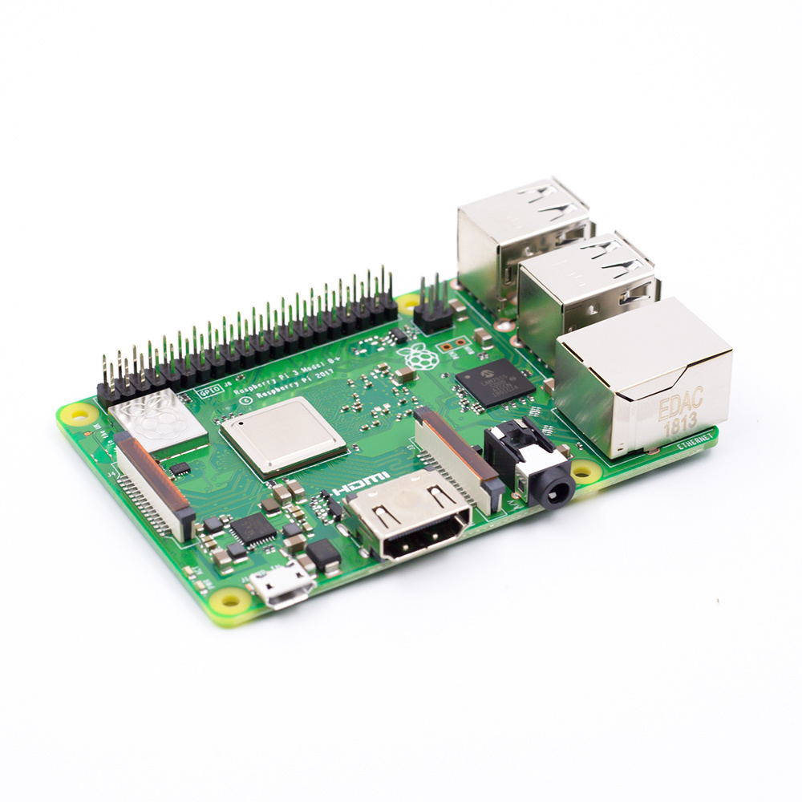

**Figure 4.1: Raspberry pi 3b+**

**2. MPU 9250 sensor**

The MPU-9250 IMU Breakout features the 9-axis MEMS sensor. Each of these 9DoF breakouts feature an MPU-9250 with a System in Package (SiP) that combines two chips: the MPU-6500, which contains a 3-axis gyroscope as well as a 3-axis accelerometer, and the AK8963, which features a 3-axis magnetometer. This breakout has been designed to be smaller than some of other offerings to fit in smaller projects. This smaller size enables it to be fixed below shock absorber. A simple four-line wire connection is required to transfer data from sensor to raspberry pi.

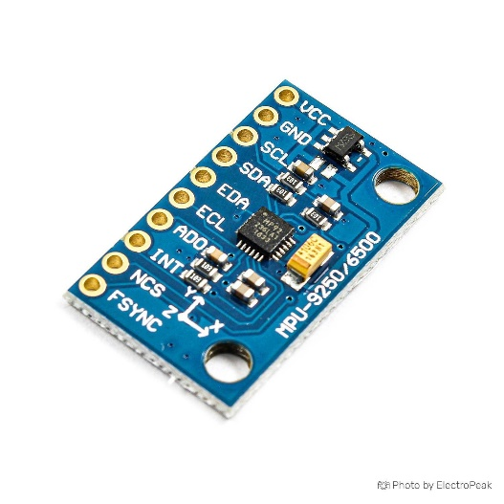

**Figure 4.2: MPU 9250U**

**3.** **NEO -6M GPS module**

The NEO-6M GPS module is a well-performing complete GPS receiver with a built-in 25 x 25 x 4mm ceramic antenna, which provides a strong satellite search capability. With the power and signal indicators, you can monitor the status of the module. Thanks to the data backup battery, the module can save the data when the main power is shut down accidentally. Its 3mm mounting holes can ensure easy assembly on your Vehicle. The stronger satellite search capability helps get signal without loss of connection. This ensured the data collected to remain resilient to errors.

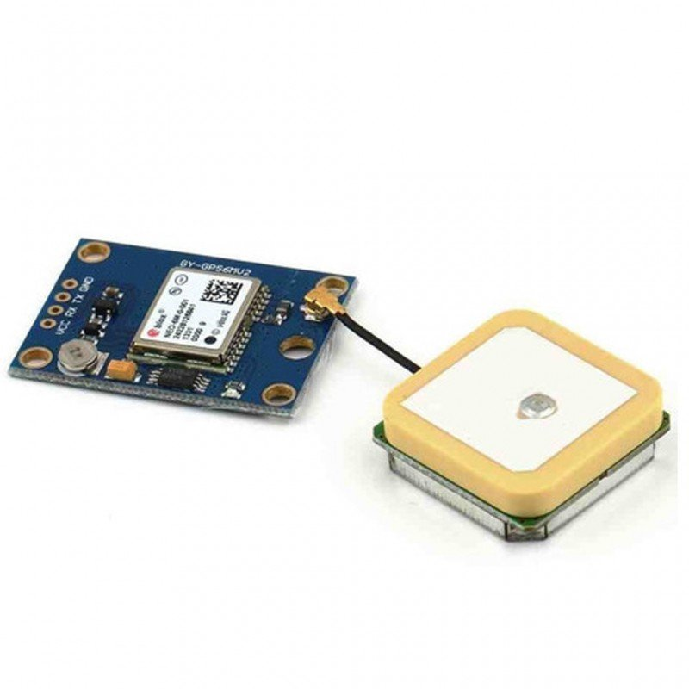

**Figure 4.3: NEO-6M GPS**

* 1. **Software requirements**

Software requirements for a system are the description of what the system should do, the service or services that it provides and the constraints on its operation.

**1. Python**

Python is an interpreted high-level general-purpose programming language. Its design philosophy emphasizes code readability with its use of significant indentation. Its language constructs as well as its object-oriented approach aim to help programmers write clear, logical code for small and large-scale projects.

This will be used in this project as it is know well and widely used language for machine learning and data analytics (Tensor, keras etc.), also provides libraries support for map computation (OSNMX, NetworkX), Map Plotting (Folium) and Data Storage (MySQL).

**2. JavaScript**

JavaScript, often abbreviated JS, is a programming language that is one of the core technologies of the World Wide Web, alongside HTML and CSS. Over 97% of websites use JavaScript on the client side for web page behaviour, often incorporating third-party libraries. All major web browsers have a dedicated JavaScript engine to execute the code on users' devices.

This is used in this project as Google API required to plot map is compatible with JS and also to generate a dynamic user interface.

**3. Google maps API**

Google Maps is a web mapping platform and consumer application offered by Google. It offers satellite imagery, aerial photography, street maps, 360° interactive panoramic views of streets (Street View), real-time traffic conditions, and route planning for traveling by foot, car, bike, air (in beta) and public transportation. These features ease us to plot maps. Which worrying about the process that is being carried out in background for map computation.

**4. Google Collab or Jupyter Notebook**

Collab and Jupyter is a project and community whose goal is to "develop open-source software, open-standards, and services for interactive computing across dozens of programming languages. This enables us to code in blocks easing modification and debugging.

**5. HTML, CSS**

The HyperText Markup Language, or HTML is the standard markup language for documents designed to be displayed in a web browser. It can be assisted by technologies such as Cascading Style Sheets (CSS) and scripting languages such as JavaScript.

Cascading Style Sheets (CSS) is a style sheet language used for describing the presentation of a document written in a markup language such as HTML. CSS is a cornerstone technology of the World Wide Web, alongside HTML and JavaScript.

**6. RASPBERRY PI OS (DEBIAN)**

Raspberry Pi OS (formerly Raspbian) is a Debian-based operating system for Raspberry Pi. Since 2015, it has been officially provided by the Raspberry Pi Foundation as the primary operating system for the Raspberry Pi family of compact single-board computers. As it is a primary operating system and is graphical based easing the work to be carried.

**7. MYSQL**

MySQL is the world's most popular open-source database. Despite its powerful features, MySQL is simple to set up and easy to use. A relational database organizes data into one or more data tables in which data may be related to each other; these relations help structure the data. SQL is a language programmers use to create, modify and extract data from the relational database, as well as control user access to the database. In addition to relational databases and SQL, an RDBMS like MySQL works with an operating system to implement a relational database in a computer's storage system, manages users, allows for network access and facilitates testing database integrity and creation of backups. MySQL has been used as DBMS to store and retrieve the GPS data of road. MySQL allow users to interact directly with a database using SQL.

**CHAPTER-5**

**Implementation**

This implementation chapter includes all the work we have done in implementing phase of this project. This implementation involves Sensor data collection, data set creation, creating and training the model, route computation and map plotting

* 1. **Sensor data collection**

In order to collect the inertial data, first the sensors such as MPU-9250U and GPS has to be placed on to be vehicle at particular locations.MPU-9250U sensor is placed below the shock absorbers so that the vibrations from the wheels are not damped. GPS has to be placed above the vehicle so that a direct satellite communication can be established easily. Below figure 5.1 and figure 5.2 shows the sensor placement on vehicle accordingly.

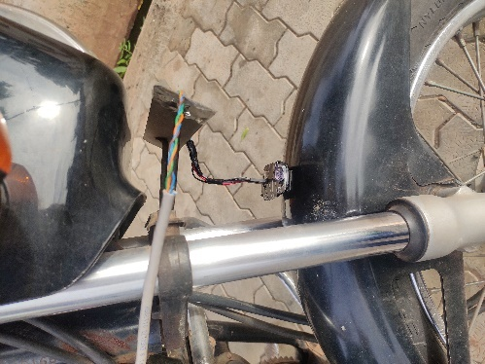

**Figure 5.1: MPU-9250u sensor mounted on motor cycle.**

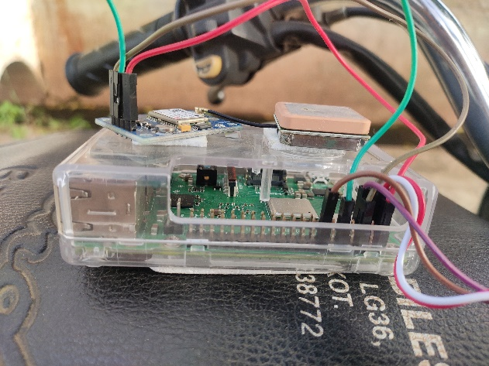

**Figure 5.2: NEO-6M GPS 9250u sensor mounted on motor cycle.**

The Circuit Connections made are shown in figure 5.3. Pin codes are shown in below table 5.1

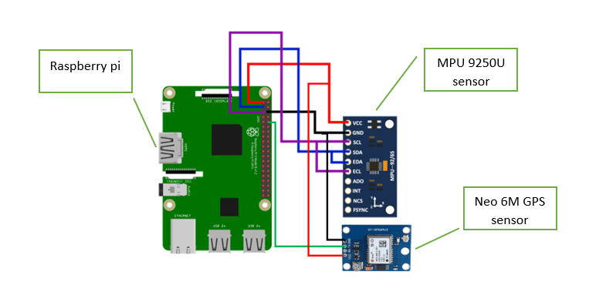

**Figure 5.3: Circuit Connections.**

**Table 5.1: Pin codes for circuit connection**

|  |  |
| --- | --- |
| **Raspberry pi pin** | **MPU 9250u pin** |
| VCC | VCC |
| GND | GND |
| I2C1 SDA (PIN 3) | SDA, EDA |
| I2C1 SCL | SCL, ECL |
|  | |
| **Raspberry pi pin** | **Neo 6-M GPS pin** |
| VCC | VCC |
| GND | GND |
| UART0 RX | TX |

After making the required mountings a program written in python is ran on raspberry pi which will continuously collecting the data from each sensor. About 100Hz from MPU-9250U sensor and 1hz from GPS. Threads have been used to make the GPS running in the background while MPU-9250U sensor data is collected at 100Hz. The data being collected is stored continuously to CSV file. A sample screen shot of the data collected is shown in figure 5.4.

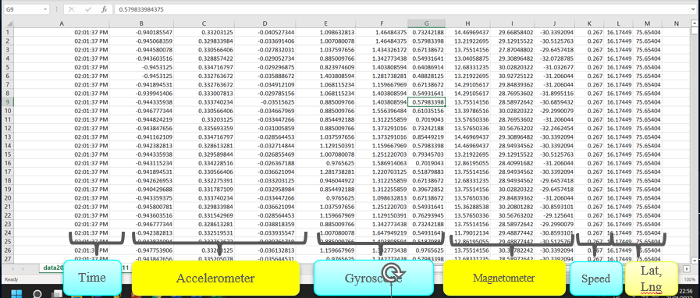

**Figure 5.4: Sensor data stored in csv format.**

Algorithm for the sensor data collection is given in Algorithm 5.1.

|  |  |
| --- | --- |
| **Algorithm 5.1: Data collection** | |
| Input: Sensor’s data | |
| Output: CSV data file | |
| **Steps** | **Description** |
| 1 | Configure MPU9250U sensor |
| 2 | Configure GPS |
| 3 | Create a thread for GPS running continuously and updating a shared variable with its location and speed. |
| 4 | Create two empty list. |
| 5 | Gather data from MPU-9250U sensors add it to a list 1 along with time, latitude, longitude and speed from shared variable. |
| 6 | Append list 1 to list 2 then empty list 1. |
| 7 | Repeat step 5 and 6 with delay so that 100Hz of data is fetched each second. For 30 seconds. |
| 8 | After collection of 30 seconds of data i.e., 3000 rows on list2. Create a new thread that will write it to a file then empty the list 2. |
| 9 | Repeat steps from 5 to 9 until program is interrupted. |
| 10 | Close the opened files and end all running threads and stop. |

* 1. **Data preprocessing**

Data preprocessing, a component of data preparation, describes any type of processing performed on raw data to prepare it for another data processing procedure. It has traditionally been an important preliminary step for the data mining process. More recently, data preprocessing techniques have been adapted for training machine learning models and AI models and for running inferences against them. The Date preprocessing done in this project is discussed in detail in section.

**1. Splitting**

The Collected data exist in a single file. This file is manually inspected for the road anomalies and those rows are selected and labelled. Inspection is done through the recoded video from where road anomalies occurring time is noted, this time is then used to identify specific rows in sensor data file. where 3 seconds of data i.e., 300 rows are sliced and labelled.

Three seconds for per sample is chosen because while splitting the data it is found that at a vehicle moving on a hump or pothole after slowing down take at most of 2.5 seconds and even research papers suggested the same. After dataset is prepared. It is found that our dataset is rich in 4 anomalies, so 4 classes were decided those are given below.

1. Potholes
2. Regular road
3. Humps
4. Worn-out road

The following splitting is carried out for 1-hour of data collected and a dataset of size 668 samples having these anomalies labeled and stored. While the other 4-hour data is left as it is to be directly classified using the ML model trained using the labeled dataset. A Visual representation of different road anomalies is shown in figure 5.5.

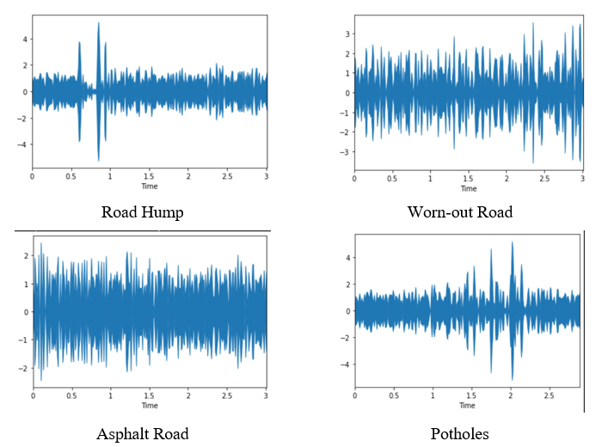

**Figure 5.5: Visual representation of different road anomalies**

**2. Normalization and spectrogram conversion**

In Order to train the model, first we need to preprocess the data collected. The data collected is normalized to 0-1 range as librosa library required the values has to be in range of 0-1 in order to convert into spectrogram. The normalized data is then converted to spectrogram to extract the features. This data is labelled and stored as a data frame. This preprocessed data is then split into training and testing data 70% and 30% accordingly.

* 1. **Creating and training the model**

A CNN Model is created and training process is carried out. After experimenting with CNN Layers, a final model that provide the highest Accuracy is finalized (shown in figure 5.7). The Accuracy resulted from the proposed model is about 90.02%. A brief information of the process carried out is shown in Chapter 3 Road classification. Layers information used in this project is provided in next section.

**1. Dense layer**

The dense layer is a neural network layer that is connected deeply, which means each neuron in the dense layer receives input from all neurons of its previous layer. The dense layer is found to be the most commonly used layer in the models.

In the background, the dense layer performs a matrix-vector multiplication. The values used in the matrix are actually parameters that can be trained and updated with the help of backpropagation.

The output generated by the dense layer is an ‘m’ dimensional vector. Thus, dense layer is basically used for changing the dimensions of the vector. Dense layers also apply operations like rotation, scaling, translation on the vector.

output = activation ( dot ( input, kernel ) + bias )

were,

* input represent the input data
* kernel represent the weight data
* dot represent NumPy dot product of all input and its corresponding weights
* bias represent a biased value used in machine learning to optimize the model
* activation represent the activation function.

**2. Relu activation function**

The Rectified Linear Unit, or Relu, is not a separate component of the convolutional neural networks' process. It's a supplementary step to the convolution operation that we covered in the previous section.

The purpose of applying the rectifier function is to increase the non-linearity in spectrogram. The reason we want to do that is that spectrogram images are naturally non-linear. When you look at any image, you'll find it contains a lot of non-linear features (e.g., the transition between pixels, the borders, the colors, etc.).

The rectifier serves to break up the linearity even further in order to make up for the linearity that we might impose an image when we put it through the convolution operation.

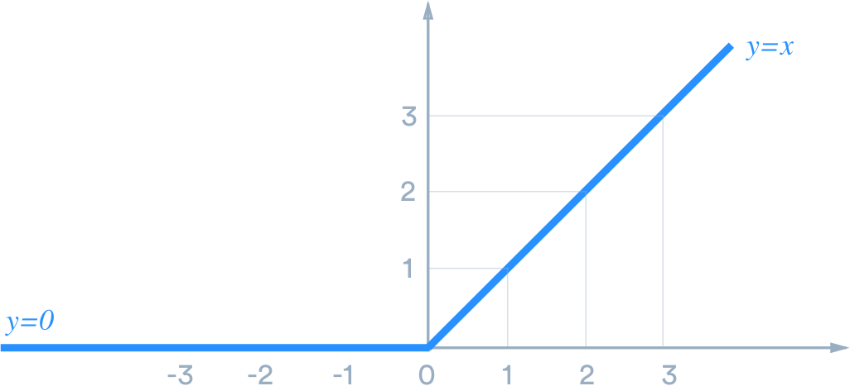

**Figure 5.6: Relu activation function.**

**3. Drop out**

Dropout is a technique used to prevent a model from overfitting. Dropout works by randomly setting the outgoing edges of hidden units (neurons that make up hidden layers) to 0 at each update of the training phase. Machine learning is ultimately used to predict outcomes given a set of features. Therefore, anything we can do to generalize the performance of our model is seen as a net gain.

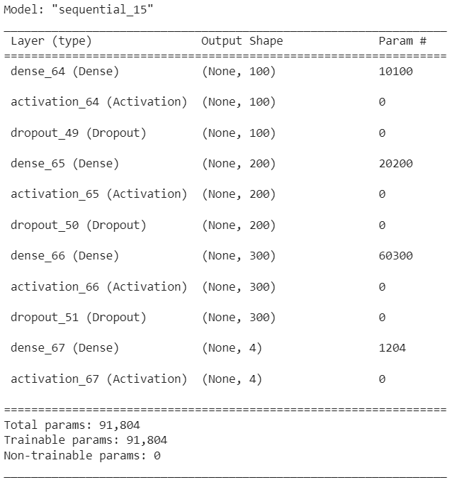

**Figure 5.7: CNN architecture.**

* 1. **Data classification.**

After model has been trained, next step to be carried out is to get the remaining data classified and store data accordingly into our database i.e., location of humps, pothole and worn-out road. MYSQL database is used to store these data table structure of that is show in figure 5.8. An algorithm for data classification is given in Algorithm 5.2.

|  |  |
| --- | --- |
| **Algorithm 5.2: Data classification** | |
| Input: CSV Data file | |
| Output: Database table with output stored | |
| **Steps** | **Description** |
| 1 | Load the Sensor data file as a data frame. |
| 2 | Slice the data frame such that each sample has 3 seconds of data i.e., 300 rows. |
| 3 | Repeat the below steps for each sample. |
| 4 | Fetch the Z-axis data of accelerometer and normalize it. |
| 5 | Convert it into spectrogram. |
| 6 | Predict the output by inputting the spectrogram created into the model trained. |
| 7 | If output is pothole, hump or worn-out then go to next step else proceed with next sample. |
| 8 | Average out the latitude and longitude rows of this sample. |
| 9 | Append this average in MYSQL table in the column named with the predicted output. The primary key is the source and destination node of route on which this has occurred. |
| 10 | If last sample end. Else proceed with next sample |

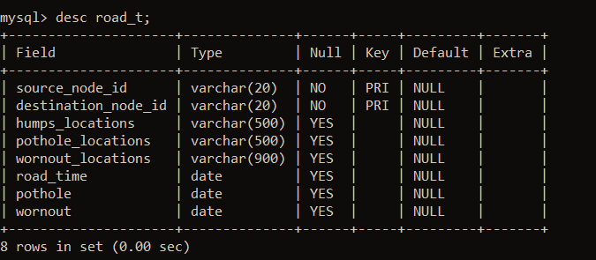

**Figure 5.8: Table structure for storing humps, potholes, worn-out road locations.**

* 1. **Route computation.**

The data stored in MySQL is then used for computing the maps. Three choices are given those are shortest path by length, time, comfortable. The path by length and time can be calculated easily as the data is readily available in the osmnx library but the comfortable one has to be chosen based on the road quality i.e., the weights have to be assigned to the route. So, after experimenting with different numbers, it is decided that a 100-meter road can have max of 2 humps, 1 pothole, 1 worn-out road patch then it can have a wight equal to its length else the weight increases with increase in anomalies as some percent of its actual length. Dijkstra algorithm is used to compute the paths. An algorithm for the path computation and map plotting is given in Algorithm 5.3.

|  |  |
| --- | --- |
| **Algorithm 5.3: Route computation and map plotting** | |
| Input: MySQL data | |
| Output: Map with route plotted. | |
| **Steps** | **Description** |
| 1 | Get the source and destination points and type of path required from user. |
| 2 | Using Dijkstra algorithm find the route between source and destination, where the weights of any edge is taken based on type selected for example type length will have weight as length of that road edge in meters, for time it will be seconds taken to travel between those edges and for comfortable it will be calculated as some function of road anomalies present in that road edge. |
| 3 | The humps and other road anomalies occurring in the path computed is fetched form database. |
| 4 | Plot the route on folium map, add pothole, humps as cluster markings and use heat map to display the condition of the road. |
| 5 | respond the user with the computed map. |

After getting the route the same has to be plotted on to maps. By using the Folium library maps is generated, different layers also been added, Ant path is used to plot the route, Cluster marking are used to plot the humps and pothole (cluster marking helps to cluster the mark on a map hence providing user a brief look of the number of humps, potholes in his path), and heatmap marking technique is used to display the condition of road.

**CHAPTER 6**

**Results and discussion**

**6.1 Results of road classification**

Initially the standard data set of roads was not available to train or test so there was need to prepare own data set. The data was collected in nearby location by travelling across various path. Data collection model was fine tuned to collect 100Hz of data per sec. Then the data collected was used to find best Machine Learning method to implement. Data obtained was found to be rich in 4 road anomalies i.e., Humps, Potholes, Worn out road and asphalt road. Data samples for each categories collected were around 200. The data set was divided in to test data set and train data set.

After experimenting with many modules, each time the accuracy has been tried to improve by changing the number of epochs and number of layers. At last, improvement in accuracy is obtained with model no 2. After augmentation of the data, accuracy is subsequently improved. Three modules with their accuracy are shown in table 6.1.

**Table 6.1 Experimentation on CNN Models**

|  |  |  |  |  |  |  |
| --- | --- | --- | --- | --- | --- | --- |
|  | **Epochs needed for saturation of validation accuracy** | **Training Sample** | **No. of filters** | **Dropout** | **Augmentation** | **Accuracy** |
| Model I | 300 | 668 | 100, 50, 25 | 0.5, 0.5, 0.5 | No | 0.8214 |
| Model II | 100 | 668 | 100, 200, 300 | 0.5, 0.5, 0.5 | No | 0.8461 |
| Model III | 80 | 4676 | 100, 200, 300 | 0.5, 0.5, 0.5 | Pitch(0.7), Noise,  Stretch(0.8), shift(-5,5) | 0.9002 |

**1. Experimenting with Model - I.**

Using the Deep learning CNN network is created with dense, activation and dropout layer. In this model the number of Epoch is set to 500. CNN network was built with dense layers of 100,50,25, drop between each layer was set to 0.5. Relu activation function was used for first three layers and final layer has sigmoid activation function. The Accuracy Vs Epoch of model I is shown in the figure 6.1 and the Loss vs Epoch of model I is shown in figure 6.2.

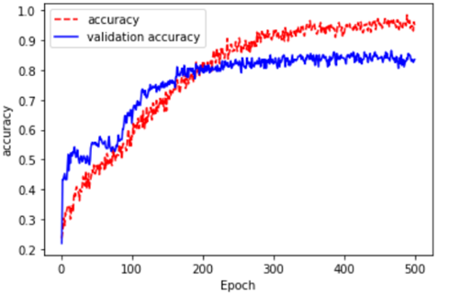

**Figure 6.1: Accuracy vs Epoch of model I.**

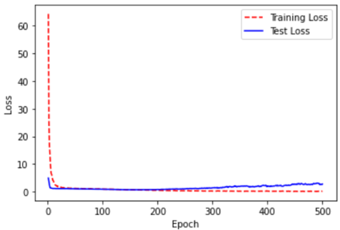

**Figure 6.2: Loss vs Epoch of model I.**

**2. Experimenting with Model - II**

In this model the number of Epoch is set to 500. CNN network was built with dense layers of 100,200,300, drop between each layer was set to 0.5. Relu activation function was used for first three layers and final layer has sigmoid activation function. The Accuracy Vs Epoch of model II is shown in the figure 6.3 and the Loss vs Epoch of model II is shown in figure 6.4.

Its is clearly visible in the figures that the curve of Val accuracy starts saturating near 100 epochs, and test accuracy starts saturating around 200 epoches.

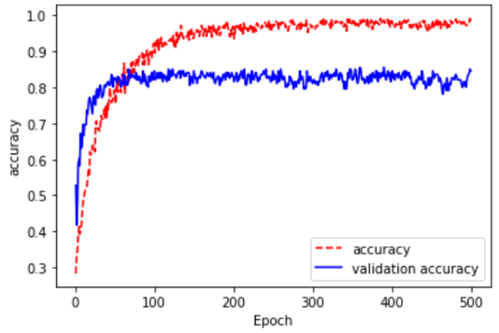

**Figure 6.3: Accuracy vs Epoch of model II.**

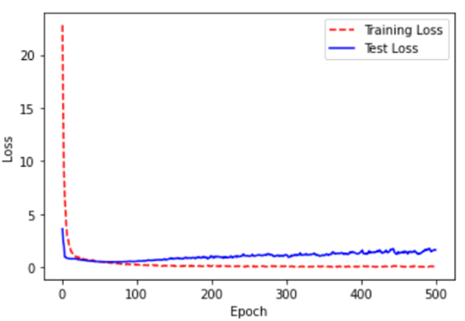

**Figure 6.4: Loss vs Epoch of model I.**

Comparing this module with our previous module number of Epoch to train has been significantly reduced. As a result of this there is decrease in training time and validation loss is reduced.

**3. Experimenting with Model - III**

The 2nd and 3rd model are same in architecture the change is the number of samples. We tried to augmentation the data with Pitch, Noise, Stretch, Shift as a result 4676 training samples was created. The Accuracy Vs Epoch of this model is shown in the figure 6.5 and the Loss vs Epoch of this model is shown in figure 6.6.

It is clearly visible in the figures that the curve of Val accuracy starts saturating near 80 epochs, and test accuracy starts saturating around 150 epochs.

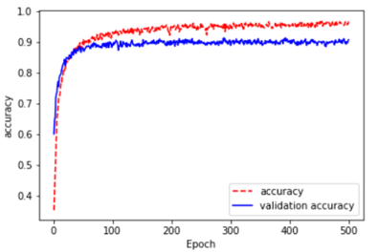

**Figure 6.5: Accuracy vs Epoch of module 3.**

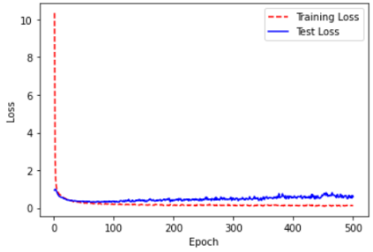

**Figure 6.6: Accuracy vs Epoch of module 3.**

Finally, the number of Epoch to train has been Again reduced and model accuracy was also increased to 90.02%. and there is decrease in training time and validation loss is reduced.

Figure 6.7 shows the comparison of training and testing accuracy of these three models. Even though the testing accuracy is much higher than final model. The Validation accuracy is much less. The model 3 shows significant improvement in validation accuracy.

**Figure 6.7: Accuracy comparison of all the module.**

Figure 6.8 shows the confusion matrix for real time data.

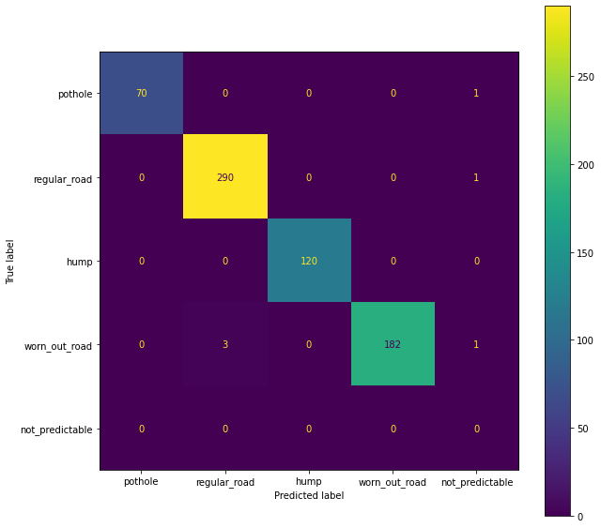

**Figure 6.8: Confusion matrix for real time data.**

**6.2 Comparing with existing system**

**1. Using Camera Sensor**

Camera sensor can be used in detecting road humps and potholes. It captures the image of the humps and pothole and then apply image classification to classify the road humps.

Image processing-based solutions at [26] and [27] had very low detection accuracy for un-marked speed breakers. W. Devapriya et al. at [26] achieved classification with true positive of 92% on marked speed hump test images and true positive of 30% on un-marked speed bump test images. At [27] authors show detection with 90% accuracy rate for marked speed bump and 4% accuracy rate for un-marked speed bump. Suchada et al. at [28] shows bump detection using gaussian mixture model with segmentation, dilation and erosion operations achieved true positive of 94.7% during daytime and 70.8% true positive during night time. The 3D vision-based approach at [29] is implemented using single road image and it works well for hump detection only on images with single vanishing point.

Camera uses color images for depth and height perception. So, the detection of hump is poor at very low-light environments.

**2. Using Ultrasonic sensor**

Another way of detecting road humps and potholes is using ultrasonic sensor. Ultrasonic can be used to measure distance from the ground by transmitting high frequency sound waves and waits for the reflected wave to hit the receiver. The distance is calculated based on the time taken by the ultrasonic pulse to travel a particular distance.

If potholes are filled with water, then ultrasonic sensor would reflect the surface of water which is same as the road level resulting in wrong output. With a lot of digital signal processing the ultrasonic sound received could be processed to identify that if it is water on the ground instead of just asphalt or soil and that information could be delivered as information. But only a completely empty potholes depth could be measured with ultrasonic measure and even that application would be really bad due to a rather wide beam from the ultrasonic transducer. That means that the accuracy would be bad. On top of it all there will be problem on the mounting of the ultrasonic sensor.

**3. Proposed approach**

Accelerometer is a sensor which converts accelerations from motion or gravity to either analog or digital electrical signals. The raw data set from the accelerometer is the acceleration of each axis in the units of gravitational force which is convertible to other units also. The raw data is represented in a set of vectors. The acceleration data is collected from pothole and hump respectively, the system collects three axis readings X Y &Z.

Using Accelerometer sensor data classification of road humps can be done irrespective of whether the humps are marked or not marked with accuracy of 100.0%. Also, the efficiency of identifying potholes in all conditions weather it is filled with water or not found more efficient i.e., accuracy of 98.59%.

Accelerometer sensor is also efficient in identifying the type of road. Efficiency of identifying the asphalt road was 99.65. And accuracy of identifying the worn-out road was 97.84%.

**Figure 6.9: Accuracy comparison of camera sensor with our module.**

**6.3 Application interface**

In today’s world any application should have an efficient Graphical user interface. An interface must attract the user to use it and must be easy to understand, can be accessed through any smart device, it should also be efficient and accurate.

The Designed Interface contains 2 pages. One to get the source and destination and other to plot the route heat map and mark potholes and humps in the maps. Figure 6.10 shows the 1st page where user has to choose the source and destination for which he wants the route, along with those 3 options of the type of route the users want is also provided. As the application is based on web any smart phone, desktop or laptop users can access. Instructions are provided to make user feel comfortable to use and instead of manually providing the latitude and longitude for source and destination, user can choose 2 points on map from which the latitude and longitude is extracted automatically and route and plotted.

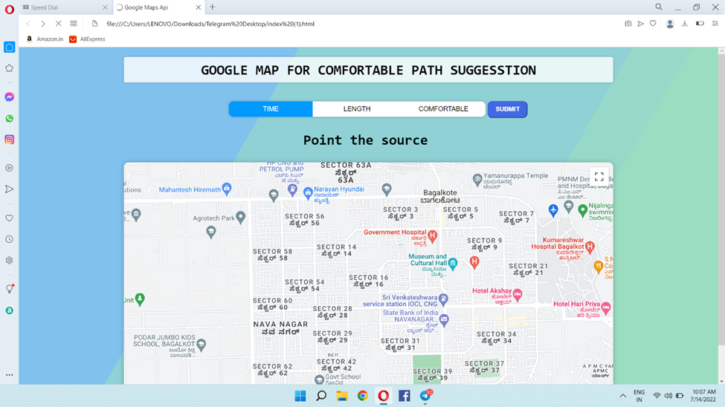

**Figure 6.10: User’s Input page**

The figure 6.11 Shows the map with the route plotted on it along with the potholes, humps marked as a cluster.

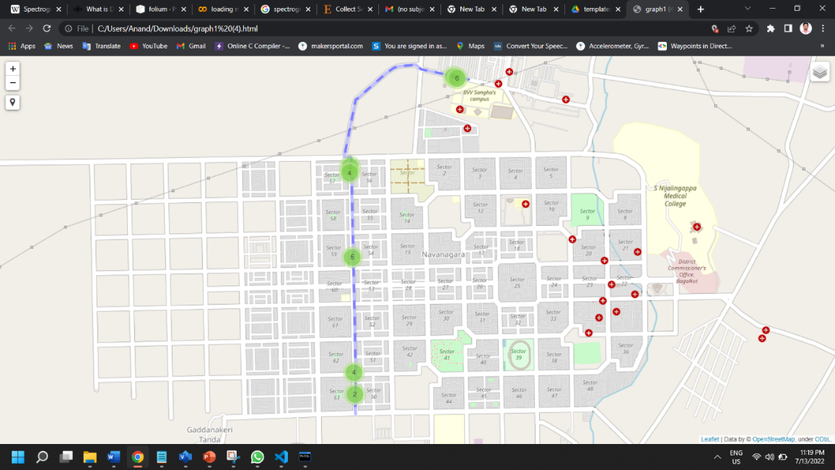

**Figure 6.11: Output page**

Multiple tile layers are provided for users to experiment and choose the one of his likes.

Figure 6.12 shows multiple tile layer provided.

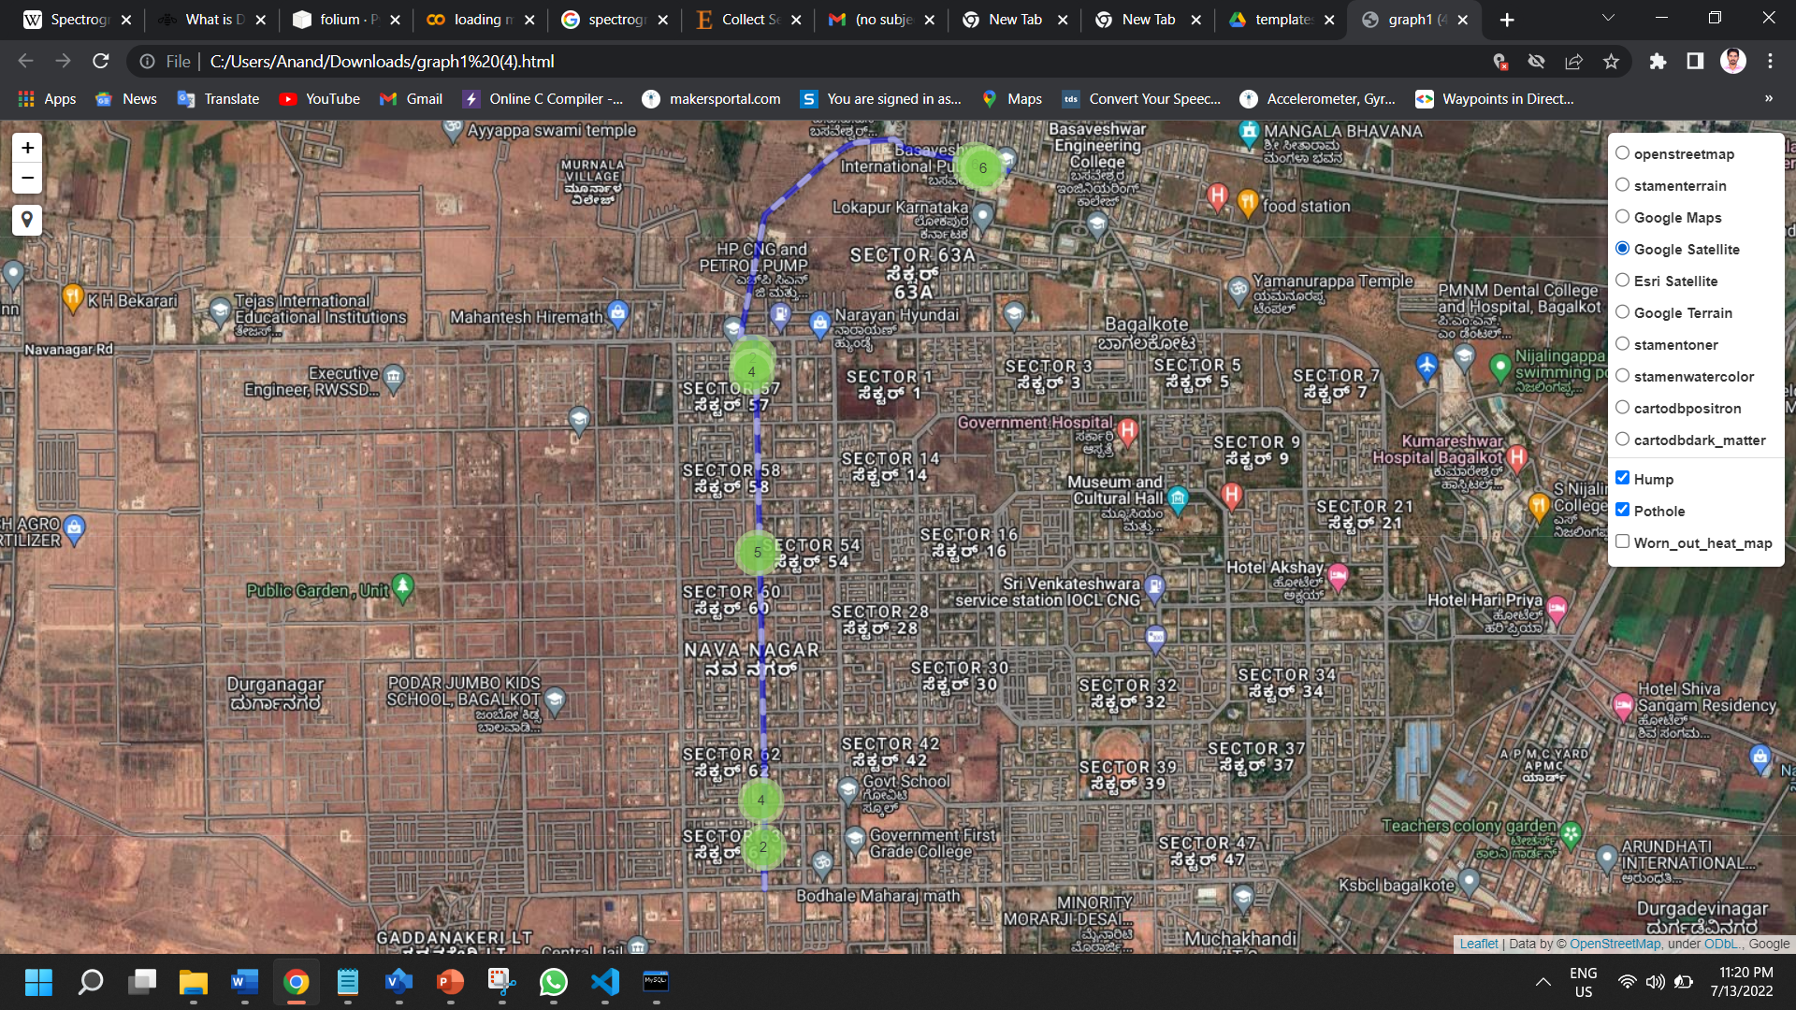

**Figure 6.12: Tile layer**

Figure 6.13 shows the humps and potholes marked.

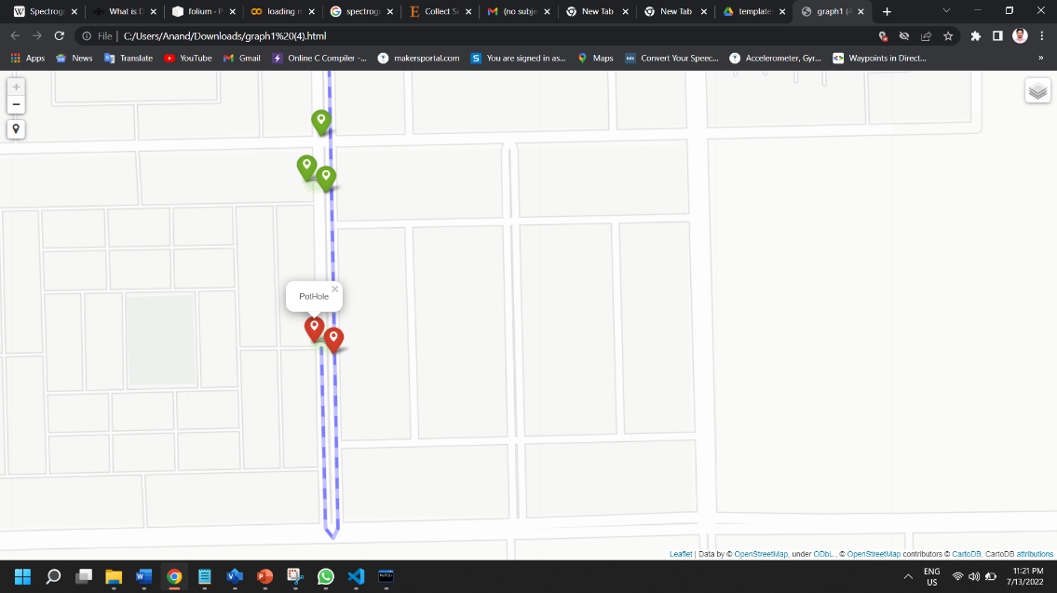

**Figure 6.13: Hump and pothole marking**

As it is necessary that along with the route and other markings, it’s also necessary to provide the amount of damage that each road has, Heat map is used to mark the worn-out road, figure 6.14 shows the heat map of the routes.

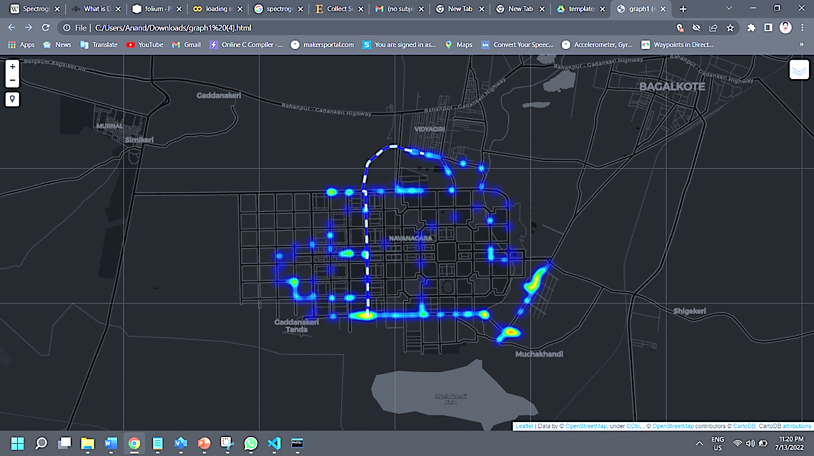

**Figure 6.14: Heat map of the routes.**

**Conclusion**

Roads are needed to be monitored continuously for roughness and other anomalies to avoid inconvenience to the road users. Road monitoring can also help to predict the estimated arrival time from one place to another. There are many ways in which road anomalies can be detected, after doing many surveys it was decided to solve the problem using this approach.

This report presents a detailed methodology of detecting road anomalies. To reach destinated goal various sensors like accelerometer, GPS, gyroscope, and magnetometer are used for collecting data of different type of roads, these sensors needed to be integrated with Raspberry Pi and the working of all the sensors has been tested and sample data is collected successfully. An accurate model with accuracy of 90.02% has been built to classify the road anomalies. Road quality analysis and path suggestion is successfully demonstrated using web-based application.

**REFERENCES**

[1] Nelson Kennedy Babu, C., Divya Priya, W., Srihari, T. and Nandakumar, R. ‘’Speed-bump Detection using Otsu's Algorithm and Morphological Operation’’. International Journal on Emerging Technologies, 11(3): 989–994, **2020**.

[2] Prof Shashikala J, Likith Rahul, Mahesh, Nagabindu R Preethi Muniraju. “POTHOLE DETECTION AND NOTIFICATION SYSTEM” (Volume:02/Issue:07/July-2020). Department of Electronics and Communication Engineering, B.M.S. Institute of Technology, Bangalore 560064, India. e-ISSN: 2582-5208. Impact Factor- 5.354, **2020**.

[3] Shyam Achary, Niraj Yadav, Sachit Agarwal, Pragya Jain, Deepak Das. “Pothole and Hump detection system using IoT”. *SAMRIDDHI: A Journal of Physical Sciences, Engineering and Technology*: Vol. 12, Issue Supplementary-1, ISSN: 2229-7111 (Print) and ISSN: 2454-5767 (Online), **2020**.

[4] Johannes Wagner, Jan Burgemeister. “Piezoelectric Accelerometers”. Manfred Weber Metra Mess- und Frequenztechnik in Radebeul e.K. Meißner Str. 58 D-01445 Radebeul. Germany: 7th revised edition, **2020**.

[5] Supratik Kumar Saha, Rishav Bhatt, Adit Gavankar, Prof. A.P. Singh. “A REVIEW PAPER ON EXISTING POTHOLE DETECTION METHODS”. International Research Journal of Engineering and Technology (IRJET). Volume: 05 Issue: 12 | Dec 2018. e-ISSN: 2395-0056, p-ISSN: 2395-0072, **2018**.

[6] Sattar, Shahram, Songnian Li, and Michael Chapman. "Road surface monitoring using smartphone sensors: A review." Sensors 18, no. 11 (2018): 3845, **2018**.

[7] Saraf Priyanka, S. "Detection of Potholes, Humps and Measuring Distance between Two Vehicles using Ultrasonic Sensor and Accelerometer." GRD Journal for Engineering, Volume 3, Issue 6, May **2018**.

[8] Jose M. Celaya-Padilla, Carlos E. Galván-Tejada, F. E. López-Monteagudo, O. Alonso-González, Arturo Moreno-Báez, Antonio Martínez-Torteya, Jorge I. Galván-Tejada, Jose G. Arceo-Olague, Huizilopoztli Luna-García and Hamurabi Gamboa-Rosales., “Speed Bump Detection Using Accelerometric Features: A Genetic Algorithm Approach”, **2018**

[9] Gah, S. K., Katsriku, F., & Gyamfi, N. K. “Using GPS and Google Maps for Mapping Digital Postal Address (GhanaPostGPS)”, **2017**.

[10] Muhammad Sholeh, Naniek Widyastuti, Meireza Pratam. “Google Map for Implementation of Geographic Information System Development Search Location SMEs”, International Journal of Engineering Research & Technology (IJERT), http://www.ijert.org, ISSN: 2278-0181, Vol. 6 Issue 02, February-**2017**

[11] Saymote, Pradip Ashok, and Mr Abhijeet Patil. "Application Of Google API with Java Script for Web mapping of Shivaji University Campus (MS)." *International Journal of Current Trands in Engineering & Research (IJCTER)* 2, no. 9: 18-26, **2016**.

[12] McFee, Brian, Colin Raffel, Dawen Liang, Daniel P. Ellis, Matt McVicar, Eric Battenberg, and Oriol Nieto. "librosa: Audio and music signal analysis in python." In *Proceedings of the 14th python in science conference*, vol. 8, pp. 18-25, **2015**.

[13] Nomura, Tomohiro, and Yoh Shiraishi. "A method for estimating road surface conditions with a smartphone." International Journal of Informatics Society 7, no. 1 (2015): 29-36, **2015**.

[14] Zhao, Xiaoyun. "Road network and GPS tracking with data processing and quality assessment." PhD diss., Dalarna University, **2015**.

[15] Dadafshar, Majid. "Accelerometer and gyroscopes sensors: operation, sensing, and applications." *Maxim Integrated [online]* **2014**.

[16] Pankaj Verma, J.S Bhatia. “Design and development of gps-gsm based tracking system with google map-based monitoring”, International Journal of Computer Science, Engineering and Applications (IJCSEA) Vol.3, No.3, June **2013**

[17] Sachin Bharadwaj, Sundra Murthy, Golla Varaprasad “Detection of potholes in autonomous vehicle”, IET Intelligent Transport Systems, Vol.8, No.6, pp.543-549, **2013**.

[18] Cao, Yibing, Yixin Hua, Junxi Zhaoa, and Shaomeng Guo. "Design and implementation of surrounding transaction plotting and management system based on google map API." *International Archives of the Photogrammetry, Remote Sensing and Spatial Information Sciences* 4: W3, **2013**.

[19] Bahrudin, Ida Aryanie, Mohd Ezree Abdullah, Rafizah Mohd Hanifa, Miswan Surip, and Ab Aziz Abdul Latiff. “Application of Google Maps API with Grails Services for Mapping Highway Construction Sites.” Advanced Materials Research. Trans Tech Publications, Ltd., March **2013**.

[20] Yagi, Koichi. "Extensional smartphone probe for road bump detection." In *17th ITS World CongressITS JapanITS AmericaERTICO*. **2010**.

[21] Svennerberg, Gabriel. Introducing the Google Maps API (Gabriel Svennerberg). Apress, **2010**.

[22] Ahmad, Suzana, Norizan Mat Diah, Nor Ashikin Mohamad Kamal, and Siti Zalekha Mohd Jailani. "Route planner mobile web application for UiTM Malaysia." *Scientific Research Journal* 6, no. 1 (2009): 1-13, **2009**.

[23] Eriksson, Jakob, Lewis Girod, Bret Hull, Ryan Newton, Samuel Madden, and Hari Balakrishnan. "The pothole patrol: using a mobile sensor network for road surface monitoring." In *Proceedings of the 6th international conference on Mobile systems, applications, and services*, pp. 29-39. **2008**.

[24] Balaguer, Benjamin, and Stefano Carpin. "Where Am I? A Simulated GPS Sensor for Outdoor Robotic Applications." In *International Conference on Simulation, Modeling, and Programming for Autonomous Robots*, pp. 222-233. Springer, Berlin, Heidelberg, **2008**.

[25] Vijay, Shonil, and Kavi Arya. "Low Cost–FPGA based system for pothole detection on Indian Roads." M-Tech Thesis, Indian Institute of Technology Bombay **2006**.

[26] W. Devapriya, C. N. K. Babu, T. Srihari. Real time speed bump detection using Gaussian filtering and connected component approach. 2016 World Conference on Futuristic Trends in Research and Innovation for Social Welfare (Startup Conclave) 2016; 1-5.

[27] W. Devapriya, C. N. K. Babu, T. Srihari. Advance Driver Assistance System (ADAS) - Speed bump detection. 2015 IEEE International Conference on Computational Intelligence and Computing Research (ICCIC) 2015; 1-6

[28] S. Srimongkon,W. Chiracharit. Detection of speed bumps using Gaussian mixture model. 2017 14th International Conference on Electrical Engineering/Electronics, Computer, Telecommunications and Information Technology (ECTI-CON) 2017; 628-631.

[29] G. K. A, M. S. Automatic hump detection and 3D view generation from a single road image. 2014 International Conference on Advances in Computing, Communications and Informatics (ICACCI) 2014; 2232-2238.